How China is blazing a path to better jobs for my American advertising students
April 6, 2014 | By Jim Ebel

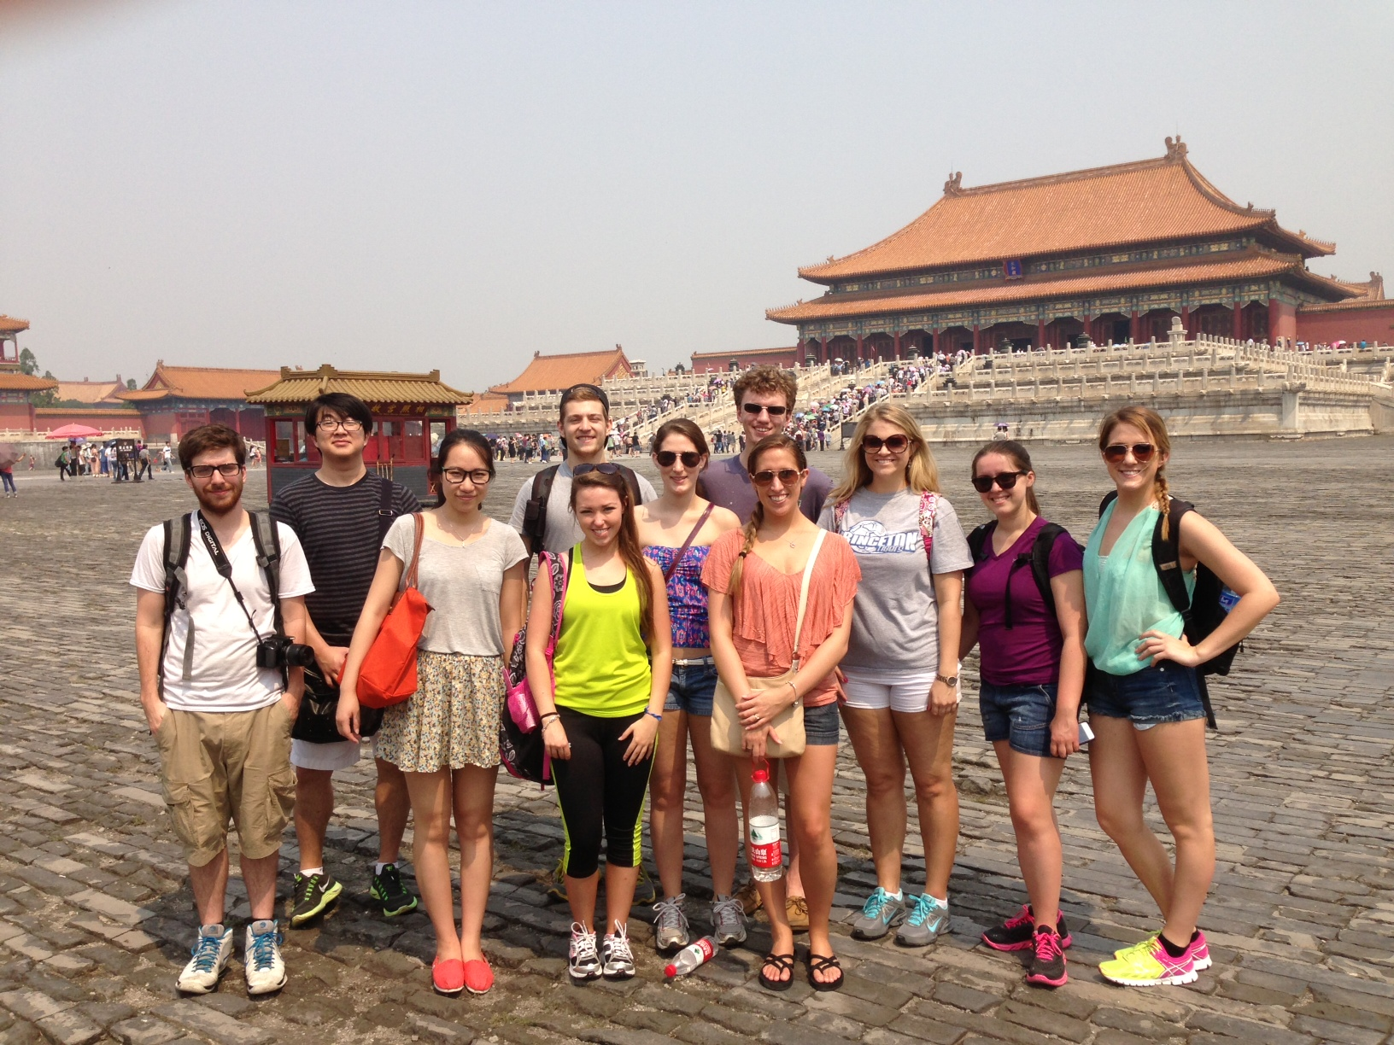
In June 2013, I spent 4-weeks in China with 10 of my top Strategic Communication students from the West Virginia University Reed College of Media. We were not the average, run of the mill study abroad program; we were thrown into a real world, real work and high intensity experience.

I work as a branding expert and serve as the Harrison/Omnicom Professor of Integrated Marketing Communication (IMC) at WVU and as Visiting Professor at Guangdong University of Foreign Studies (GDUFS), in the Peoples Republic of China. As somebody who is not academic by profession, I instead developed my expertise by helping to position and launch 200 brands in 70 categories over the past 23 years through my positioning consultancy, CenterBrain Partners. I have been fortunate enough to work with global brands and household names such as Huggies, KFC, HSBC, Bridgestone and Fruit of the Loom.

In 2012, I was invited to teach for five weeks at the Guangdong University of Foreign Studies (GDUFS) in Guangzhou, China. It was at this time that I started to think about how I could build a program that would expand the knowledge of global branding and integrated marketing communication (IMC) among WVU’s and GDUF’s Strategic Communication majors. These majors are the brand and advertising managers of the future; they need global perspective.

The outline of my program consisted of:

1. A 5-day intense course of study in branding and integrated marketing communication (IMC) with a combined group of Chinese and American students.
2. Practical application of classroom skills through nightly field study in Chinese retail markets.
3. An IMC internship for WVU students in Chinese companies.

In late 2012, I began to coordinate an exchange with my colleagues at Guangdong University of Foreign Studies (GDUFS). Most importantly, I started to sell the idea of a China exchange to WVU strategic communication majors.

I marketed the exchange to the Martin-Hall Agency, a student led integrated marketing communications agency, which I helped a group of students to establish in 2011. The agency gives students real-world experience as they work with national, regional and local clients on real projects for real money.

Despite the exchange not being fully planned at this point, my entrepreneurial background pushed me to sell and build the idea concurrently; I like to get something right up to the point where it is ready to sell, and then de-bug it as we move towards the launch. This is a common approach in app development.

Many WVU students don’t have experience with foreign travel and China is a long way from Morgantown, so I knew that positioning the exchange would be critical. I turned to a tried and true approach: exclusivity.

I offered the exchange only to the top students and made it clear that the selection process would be brutal, with only the best of the best invited to go.

This approach tends to surface Type A personalities; the competitive, the self-assured, and those not easily discouraged. This personality is exactly what you need to make it in China for four weeks, especially when most of what you will be experiencing is new, sometimes strange, and frequently flat out hard.

To my amazement, 10 students expressed interest and passed muster. I had planned on 5 students maximum, so I had to make a quick assessment as to whether I could manage 10. My gut said yes, and it proved to be right.

I take a service approach when it comes to teaching and I find it easy to be successful in higher-ed. I am only interested in conveying useful knowledge to students and I’m only interested in helping them to become successful.

I freely give what was freely given to me, sometimes in a very direct and demanding way, but always authentically. Students who work with me know that I will walk through walls for them, which in turn makes them willing to walk through walls for me. It’s a relationship built on my 50% rule. That rule says you do 50% and I’ll do 50%. When you drop below 50%, I’ll stop until you catch up.

The students I took to China lived up to my 50% rule, often doing their 50% before I had to do mine. That’s a mark of professionalism. They immersed themselves in a strange culture, kept their composure (at least outwardly), took risks, figured out solutions to difficult issues (like getting off at the wrong subway stop on the way to their internship and having no Chinese language skills), made lifelong friends and connections, and most importantly, they grew up.

Now, in 2014, these students who were in China less than a year earlier are entering the world of work. They are leveraging their unique China experience to differentiate themselves from their peers. The stories that they can tell recruiters are interesting, and they convey them with the self-confidence that only comes from accomplishing something valuable; they are getting good jobs and commanding above average salaries.

This year, I am taking a new risk. I am increasing the number of students by 70%, to 17. I will push these 17 even harder than last year’s group, because last year’s group set a benchmark and taught me that I can.

I am requiring more, expecting more, demanding more and so far, I’m not disappointed with what I’m seeing. Leaders are emerging in this year’s group and peer pressure is getting work done earlier. The group has figured out that I’ll point them to China, not push them there or pull them through. We leave for China in two months and I am confident that my risk will pay off.

Ultimately, what we’ve built is a new brand of global exchange, one that my students and I believe is a new standard. Most importantly, China is paving the way to good jobs for our students.

This year’s group has even developed a logo for the exchange, which I am pleased to unveil now.

____________________________________________________________________

About the author:

Jim Ebel serves as the Harrison/Omnicom Professor of Integrated Marketing Communication at the Reed College of Media at West Virginia University. He is also President and Founder of CenterBrain, Inc. Jim has over thirty years of integrated marketing experience, and has identified the positioning and strategy for over 200 successful new brands. Together, these brands account for over $4.0 billion in incremental annual sales for companies that include Abbott, Kimberly-Clark, HSBC, Elmers, Yum Brands, Bob Evans and Chiquita.

